Batch Content Center Export

## Help document

# Setup of Inventor project

For correct behavior of Batch Content Center Export tool, separate Inventor project needs to be configured.

1. Create Inventor project with following parameters:
   1. Path, where should exported Content Center files go
   2. Library, which you want to export

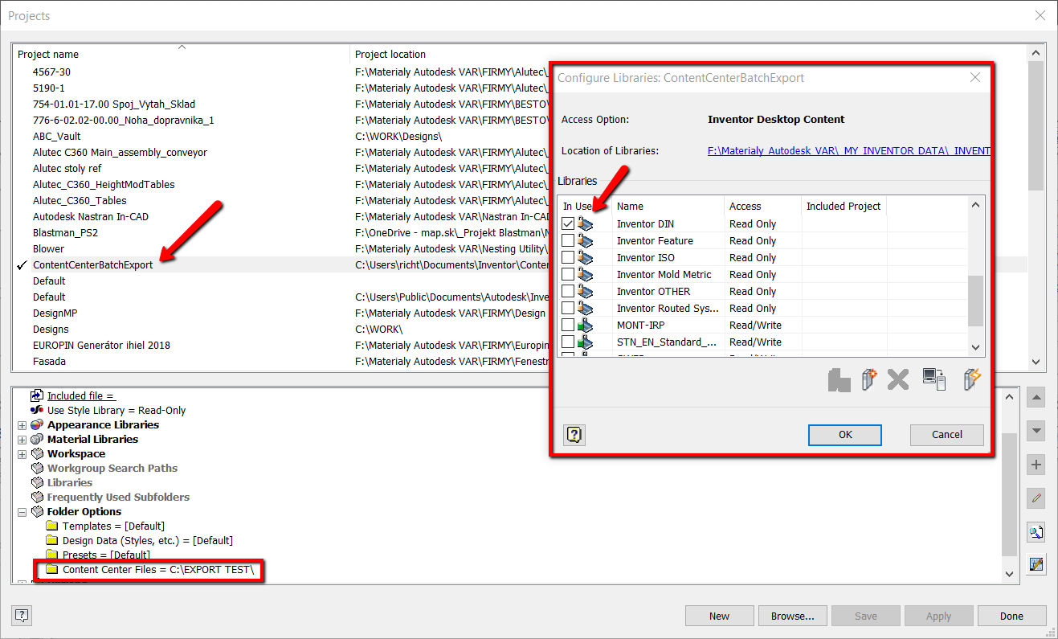

1. Close Inventor
2. Run tool BatchContentCenterExport.exe
3. Click button **Load CC library**

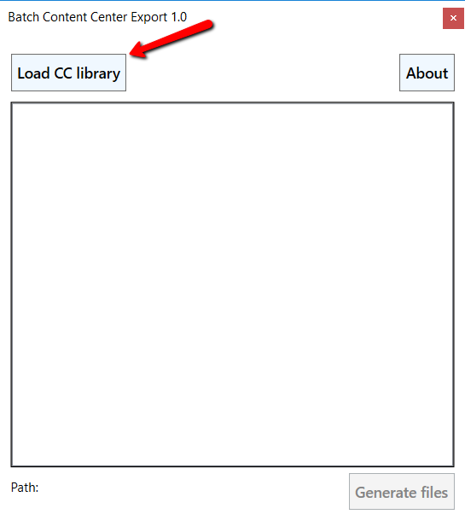

The tool starts Inventor on the background and loads the structure of selected library.

It can take one minute.

1. Select with CTRL and SHIFT combinations of all families and categories, which should be generated.

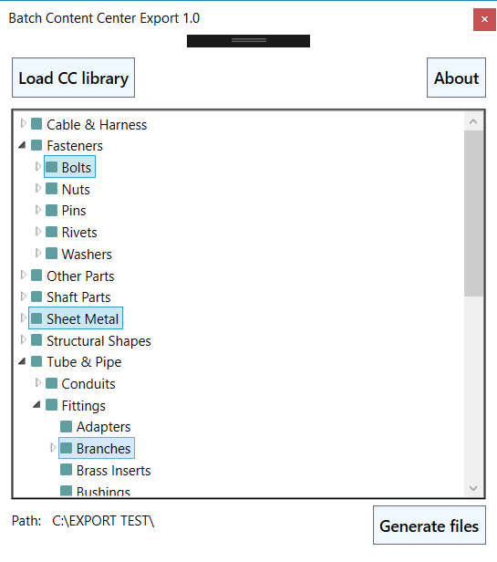

1. Path shows where you can find the generated files, path is taken from the last active project in Inventor.

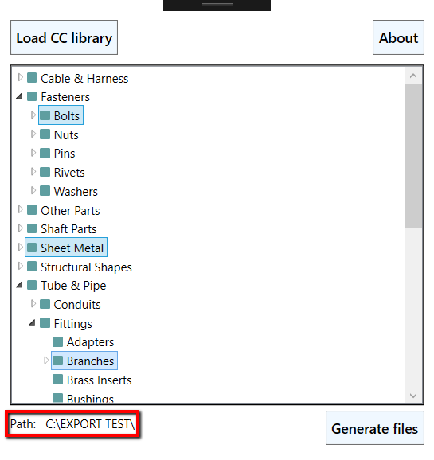

1. Click **Generate files**. We do not recommend generating all parts in one time, because of time reason and RAM memory overflow could happen. The files start to generate in the path, after generating one set, you can generate another. After generating more than 1000 files it is recommended to close and reopen the tool to restart Inventor on the background.

